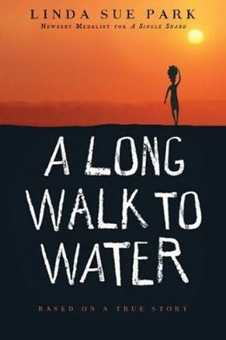
P.S. DuPont Middle School
School-wide Literacy Initiative

Dear Parents and Guardians,

One of the goals of administration, teachers and staff at P.S DuPont Middle School is to create a community of literacy. With this goal in mind the teachers began a new initiative, a school-wide literacy program, for the 2014-2015 school year. This program involved all staff members and students reading the same book, Seedfolks, by Paul Fleischman, at the beginning of the year. Due to the initial impact the program had in 2014-2015, we continued the school-wide literacy program during the 2015-2016 school year. All staff members and students read the book, Jackie’s Nine: Jackie Robinson’s Values to Live By, by Sharon Robinson. Throughout both years, the books were revisited through projects and discussions across all subject areas. This year we continue the literacy program and all staff members and students will be reading the book, A Long Walk To Water, by Linda Sue Park. Through this project, we hope to, again, begin the year with a shared literary experience and nurture a continued passion for reading.

Thank you so much for your continued support this year. We hope that parents will also participate in reading this book to continue the rich conversations about literature that are so necessary for literary growth.

If you have any questions or concerns, please feel free to contact Tracy Selekman at tracy.selekman@bsd.k12.de.us

Warm Regards,
Tracy Selekman

